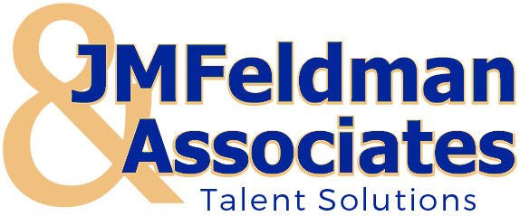 | 3701 Old Court Road – Suite 21A  Baltimore, Maryland 21208  410.486.2211  joe@jmfeld.com  www.jmfeld.com

How to Reopen Your Business as Safely as Possible During COVID-19
Posted by David Pong, M.D. on Apr 27, 2020
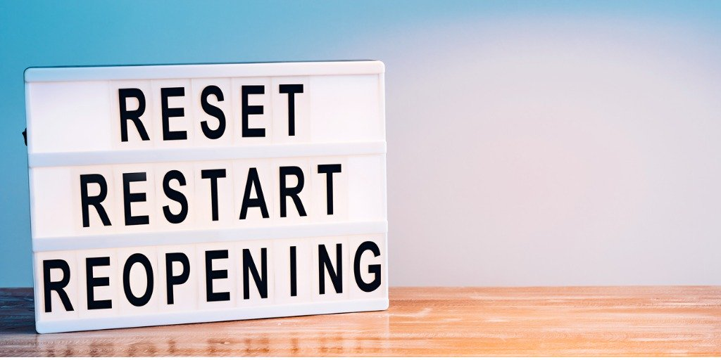
As we reach the peak of the coronavirus pandemic, most businesses are planning for how to reopen safely during COVID-19. Even as we start to see a decline in new cases, it will be important to wait several weeks after the peak to allow the diminished risk to take effect. Only then will we be able to safely return to our new normal.
As doctors providing patient care during this pandemic, we are also counseling our executive health program clients throughout the country on how to safely reopen their businesses, while at the same time determining the safest way to reopen our own business. Knowing there's a greater need in the community for this advice, we're happy to share it with everyone who is attempting to balance safety with economic reality.
Interested in getting sound medical advice to aid your planning process as you reopen your business? We are offering free consultations with advice from a physician. Click here to request a meeting.
As you think about reopening your business, plan with the longer-term in mind. Be prepared to implement strategies that will be in place for many months, and not just a couple weeks. It is likely that the COVID-19 risk will remain high for at least the next year until a vaccine can be developed and distributed on a large scale.
We will get better at treating the virus over time, which will help, but it will take a continued commitment to social distancing guidelines and strategies to reduce the risk to your employees and your customers as much as possible. The alternative is dealing with a viral outbreak at your office, and no one wants that.
When thinking about reopening, you should focus on three things: deciding which employees to bring back to the office first, promoting and practicing social distancing at the office, and encouraging healthy lifestyles from all employees.

1. Bring only the most essential, most required, and least risky employees back to work first.
With time, employees will slowly return to the workplace. But be careful about the rate and staging which people come back first. This process needs to be slow and methodical to ensure no employee is put at risk and all employees understand their role in maintaining as safe an environment as possible. Base your decisions on three factors:
- The individual health risk of each employee based on age and health status. COVID-19 impacts older individuals (over 60) and those with underlying health conditions (obesity, hypertension, diabetes, pulmonary disease, asthma, and smokers) the most. These employees, along with those that are immunocompromised, should continue to work at home. It isn’t worth the risk.
- How essential their job is to be at the workplace instead of at home. One post-COVID-19 development will be an increase in full-time remote workers. In the immediate future though, while the virus lingers, don’t bring employees back that can do their job just as well from home, even if they aren’t at a higher risk due to their age or health status. With the virus still hanging around, limiting close contact will continue to be an effective strategy, and it’s easier to do that with less people overall at the office.
- How essential they are to your business. Are they a C-Suite executive, a vital salesperson, or an individual filling an indispensable role? Certain roles are just more effective in the office. But you should only bring these individuals back after also considering their age and health status and whether they can work from home. Your 60-year-old CFO might be very important to your business. But if they are performing just fine at home, let them continue to stay home.

2. Continue practicing social distancing, and then some, as much as possible.
With employees back at the office, it will be critical to continue practicing basic social distancing guidelines, while also implementing specific workplace policies to limit the risk to your employees. Your employees will go from spending most of the day around the same few people at home to spending most of the day around more people, and then dispersing back home every night. If not handled properly, your office could become a petri dish for viral contamination and put not only your employees, but also their families, at risk. Some suggestions:
- Keep 6-10 feet apart as much as possible. Don’t linger in break rooms or around someone’s desk.
- If you have private offices, recommend employees close their door while in the office. While in public or shared areas including hallways, always wear masks.
- Consider rearranging communal workspaces to separate employees from sitting too close to each other.
- Limit in-person meetings at much as possible. If absolutely necessary, be sure to sit 6-10 feet apart.
- Encourage use of instant messaging technology, email, or a good old-fashioned phone call, as opposed to walking down the hall to pop into someone’s office for a quick question.
- Wear a face mask at all times — either a surgical mask or a homemade cloth mask. Keep N95 masks for healthcare workers due to continued PPE shortages for those who need this higher level of protection the most.
- Encourage employees to wash their hands or use hand sanitizer whenever they think about it.
- Keep public doors, including perimeter facility doors and bathroom doors, propped open if possible.
- When your employees go home, encourage them to put clothes and cloth masks into the laundry immediately. Leave shoes outside and spray them down.
- Encourage a culture of community where you are all in it together. Wear your masks to protect everyone else too, not just yourself.
Some employers are considering more extreme measures like required temperature checks and antibody testing or hiring a nurse to check symptoms at the door. These are expensive measures for any business, particularly small businesses, and they are not foolproof.
Exposure to the virus can occur 2-3 days prior to any symptoms appearing, so if one of your employees spikes a fever, it may just tell you that your business has been exposed for the last 48 hours. And you can have the antibodies, but not necessarily be immune to getting COVID-19 again or a different version of it as the virus mutates with time.
That is why it’s so important to wear a mask, wash your hands, limit unnecessary interactions, and stay as far apart as possible.

3. Double Down on Your Wellness Program. Now Is the Time to Get Healthier.
Never has there been a better time, or a more important time, to double down on any wellness initiatives and encourage your employees to get healthier. We likely have a full year, at least, before a vaccine is developed.
Improving our health — eating healthier, exercising more, sleeping better — helps enhance the immune system. By living a healthy lifestyle, we improve the chances that we will be strong enough to fight the virus if we contract it before a vaccine is developed. Given that some estimates indicate between 50%-80% of the world’s population will be exposed to the virus, it’s critical that we do everything possible in advance to give our body the tools it needs to ward the virus off.
That might involve restarting a corporate wellness program administered by HR. It must just involve encouraging all employees to take a break and go for a walk outside at least once per day. It might even involve implementing an executive health program or executive physicals at your company.
But at the very least, it means creating a culture that that promotes getting our weight down, working on nutrition habits and blood sugar levels, stopping smoking, and moving more. By helping your employees improve their health, you’ll be helping protect your business as well.

